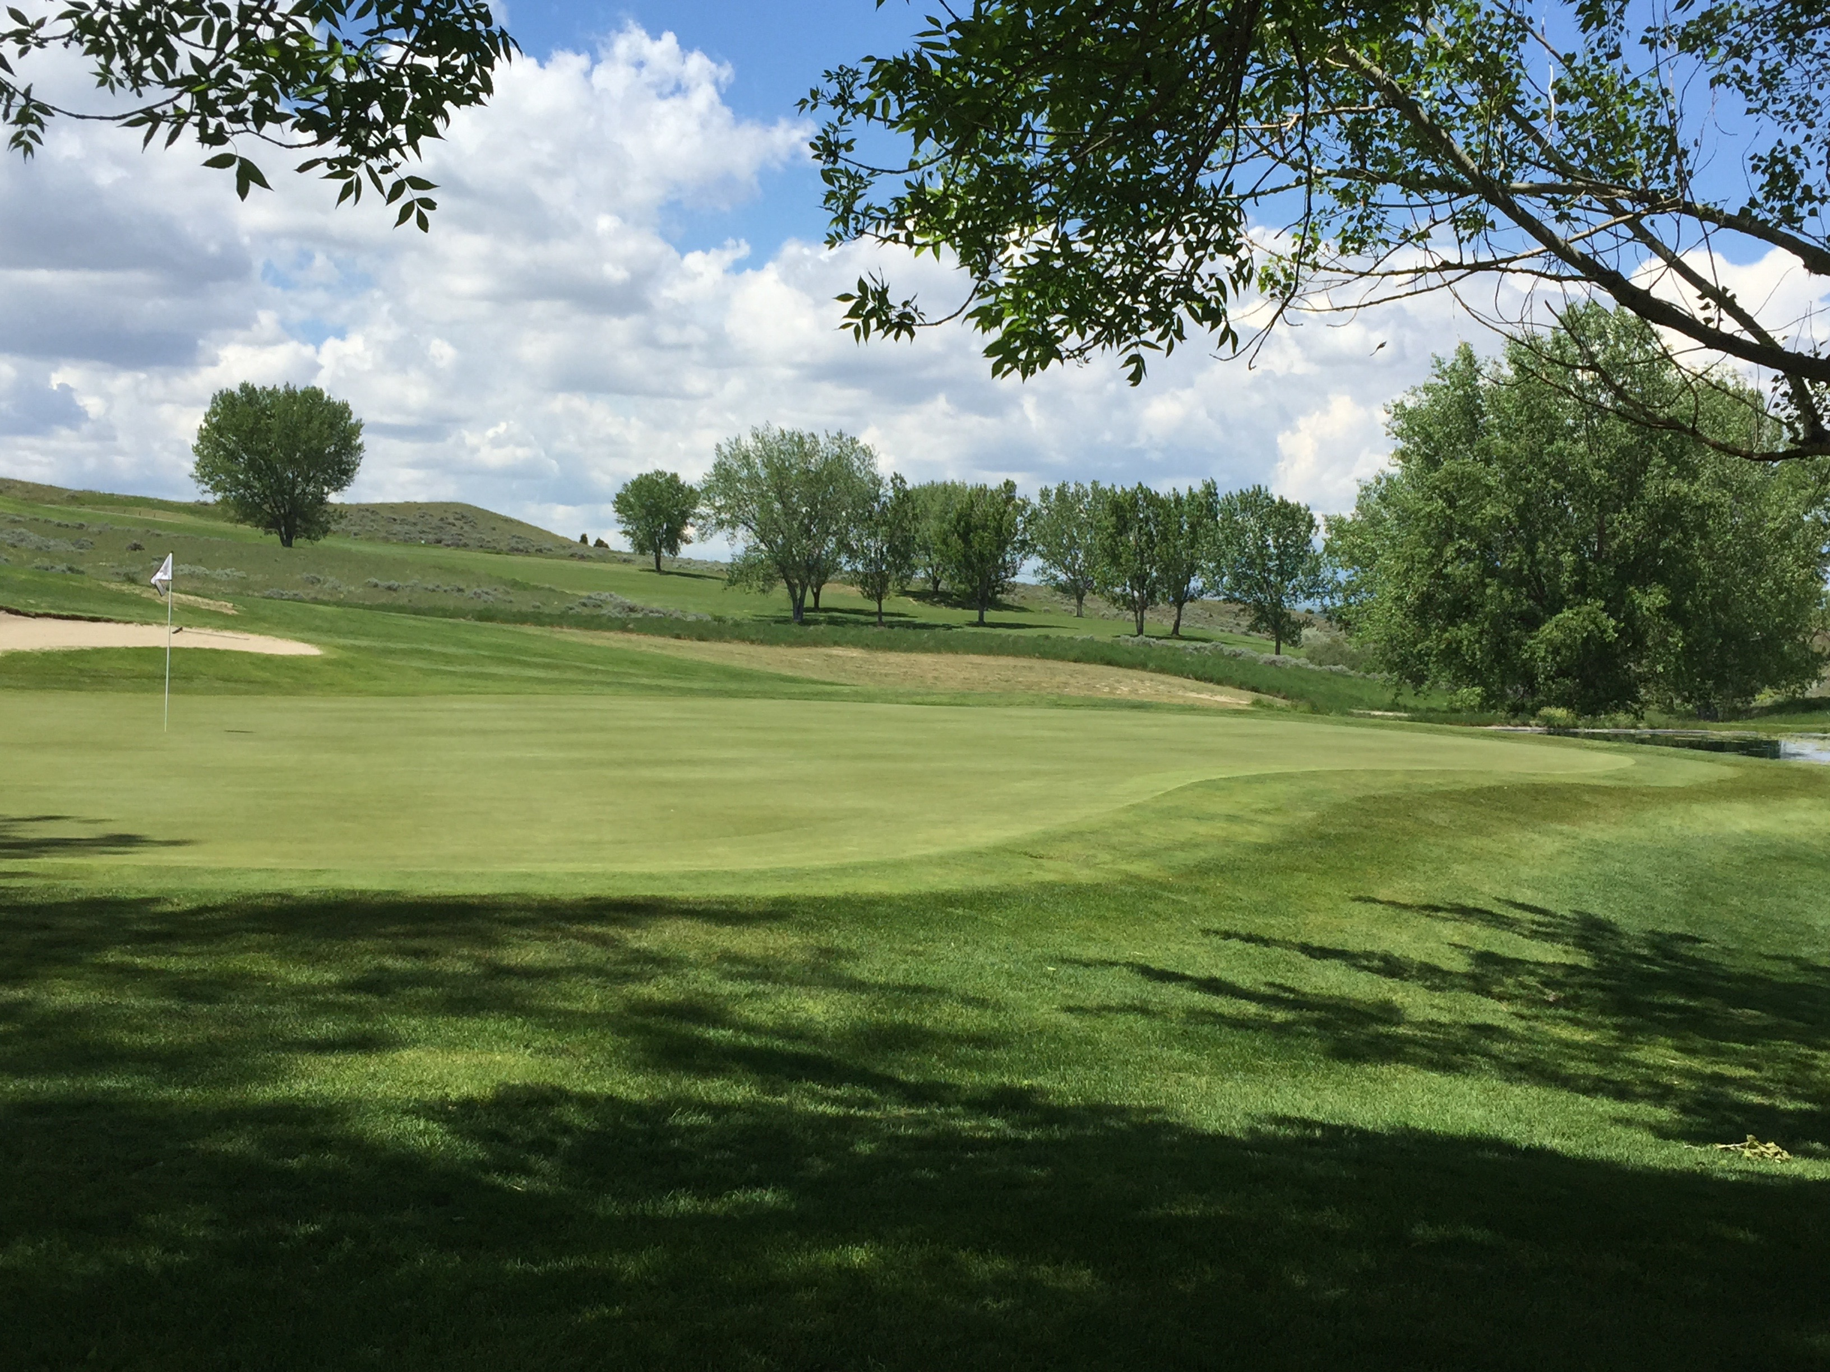
BILLINGS HEIGHTS EXCHANGE CLUB ENTRY FORM

2022 HEIGHTS EXCHANGE CLUB GOLF TOURNAMENT
PRYORCREEK GOLF CLUB

September 16th, 2022: 9:00 A.M. SHOTGUN START
Registration 8:00 AM

$125.00 PER PERSON
$500.00 PER TEAM – 4 PERSON TEAM
Full Payment is Required before tee off

ENTRY FEE INCLUDES GREEN FEES, CART, LUNCH & FLAG PRIZES
MAIL ENTRY T0 THE ADDRESS BELOW OR CALL JEN MCGLONE AT (406) 672-4836 OR BRETT ARNOLD AT (406) 209-0131. YOU MAY ALSO E-MAIL THE FORM TO jkmcglone1@gmail.com

HEIGHTS EXCHANGE CLUB
PO BOX 50245
BILLINGS, MT 59105

TEAM NAME: ________________________________________________________________

Golfer Name | Handicap (Max 24) | Phone Number | Email Address

=================================================================================
THANK YOU FOR YOUR SUPPORT OF OUR COMMUNITY. ALL PROCEEDS BENEFIT THE HEIGHTS EXCHANGE CLUB IN THEIR PURSUIT TO PREVENT CHILD ABUSE.

Please complete the Registration Form and return on or before September 9th, 2022.

